Pickling/Error Handling Write Up

Introduction:
During this module, we learned the basics of pickling and unpickling scripts as well as basic error handling concepts. Below, I detail my process for creating a simple script that pickles user input data in a text file for name/age and show how I utilized the basic error handling commands
Process Details
I chose to create a script that takes in user input for name/ age and puts that into a text file. Below is a screenshot of my code that defines 2 variables to take that user input and store it in a dictionary.
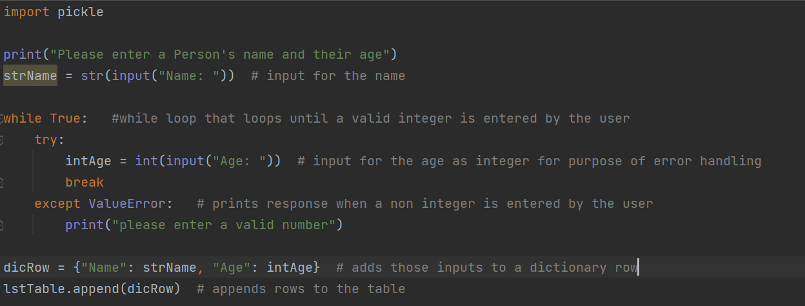
To demonstrate basic error handling, I chose to require an integer for the age input and created a while loop that would stop the code when incorrect input was given and would not continue until an integer value was entered. This likely is not best practice as a developer, but I felt it demonstrated the concept well.

I then used the dump command to pickle the input in a text file and used the load command to unpickle the information as shown below. I added a print statement for both blocks to show the similarities between the two dictionary rows
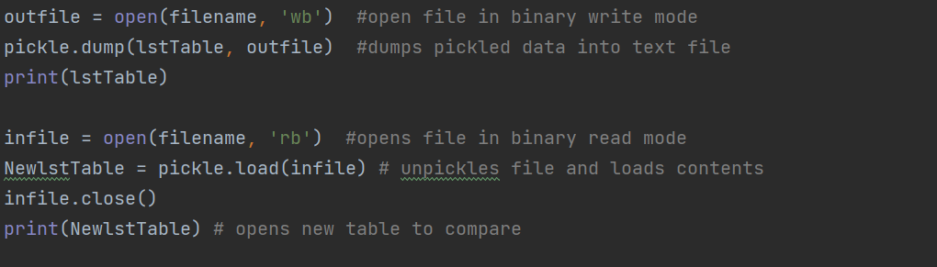
Insights and Conclusions
While this script was very simple, I believe it demonstrated the basic concepts of pickling and error handling.
The only bug I ran into while doing this assignment was a “ran out of input” for the loading command that went away on its own and I’m still not one hundred percent sure what it meant.

